Study Guide prepared by

Catherine Bush

Barter Playwright-in-Residence

***Tuck Everlasting***

Adapted by Mark Frattaroli from the novel by Natalie Babbitt

*Especially for Grades 3-10

**By the Barter Players, Barter Smith Theatre Fall, 2022**

**(NOTE: standards are included for reading the novel *Tuck Everlasting* by Natalie Babbitt, seeing a performance of the play, and completing the study guide.)**

**Virginia SOLs**

**English** – 3.1, 3.2, 3.4, 3.5, 3.7, 3.9, 4.1, 4.2, 4.4, 4.5, 4.7, 4.9, 5.1, 5.2, 5.4, 5.5, 5.7, 5.9, 6.1, 6.2, 6.4, 6.5, 6.7, 6.9, 7.1, 7,2, 7.4, 7.5, 7.7, 7.9, 8.1, 8.2, 8.4, 8.5, 8.7, 8.9, 9.1, 9.3, 9.4, 9.6, 9.8, 10.1, 10.3, 10.4, 10.6, 10.8

**Theatre Arts** – 6.5, 6.6, 6.7, 6.17, 6.18, 6.21, 7.6, 7.7, 7.18, 7.20, 8.5, 8.12, 8.18, 8.22, TI.10, TI.11, TI.13, TI.17, TII.6, TII.9, TII.12, TII.15, TII.17

**Tennessee/North Carolina Common Core State Standards**

**English Language Arts – Reading Literature:** 3.1, 3.3, 3.4, 3.5, 3.6, 4.1, 4.3, 4.4, 4.5, 4.6, 4.7, 5.1, 5.3, 5.4, 5.6, 6.1, 6.4, 6.6, 6.7, 6.10, 7.1, 7.4, 7.6, 7.7, 7.10, 8.1, 8.4, 8.6, 8.7, 8.10, 9-10.1, 9-10.4, 9-10.7, 9-10.10

**English Language Arts – Writing:** 3.1, 3.3, 3.7, 4.1, 4.3, 4.7, 4.9, 5.1, 5.3, 5.7, 5.9, 6.1, 6.4, 6.6, 6.7, 6.9,7.1, 7.3,7.7, 7.9, 8.1, 8.3, 8.7, 8.9, 9-10.1, 9-10.3, 9-10.7, 9-10.9

**TCAPS**

**Theatre** – 3.6.1, 3.6.4, 3.7.1, 3.7.2, 4.6.1, 4.6.4, 4.7.1, 4.7.2, 5.6.1, 5.6.4, 5.7.1, 5.7.2

**Theatre 6-8** – 3.2, 6.2, 7.1 **Theatre 9-12** – 1.3, 7.1, 7.2

**North Carolina Essential Standards**

**Theatre Arts** – 3.A.1, 3.AE.1, 3.CU.2, 4.A.1, 4.AE.1, 5.A.1, 5.AE.1, 6.A.1, 6.AE.1, 7.A.1. 7.AE.1, 8.A.1, 8.AE.1, 8.CU.2, B.A.1, B.AE.1, B.CU.2, I.A.1, I.AE.1

**Setting**

In and around the village of Treegap. 1880

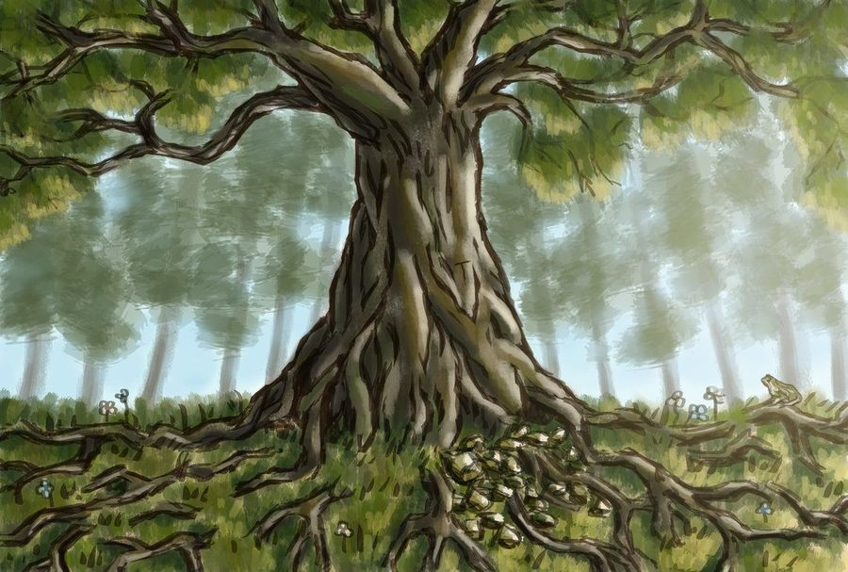

**Characters**

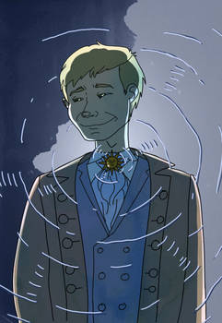

**Winnie Foster** – A young girl

**Granny Foster** – Winnie’s grandmother

**Angus Tuck** – head of the Tuck family

**Mae Tuck** – Angus’s wife

**Miles Tuck** – the older son

**Jesse Tuck** – the younger son

**Stranger in the Yellow Suit** – searching for the Tucks

**Note: Cast Size and Doubling of Actors**

In this production of *Tuck Everlasting,* we will be using six actors; one actor will be playing two roles. Doubling of actors requires distinction between characters. In this production, characters will be distinguished by costume, voice and other physical character traits.

**Vocabulary Words**

suffocating

dog days

immortal

peculiar

witchcraft

whit

changelessness

parson

vigorous

penetrate

loft

dimension

silhouette

unravel

destination

kidnapping

witness

blackmail

constable

rouse

accommodations

gallows

gander (verb)

peculiar

tarnation

advertise

demonstration

anticipation

oppressive

budge

accomplice

parched

threaten

**Define each of the vocabulary words listed above then write sentences using them. Remember: anyone reading your sentence should be able to understand the word from the context in which it is used.**

**Synopsis**

Tuck Everlasting is the story of the Tuck family, who drank water from a mysterious well and from that point on, stopped aging. Winnie, a young girl who lives in isolation with her mother and grandmother, spots a boy drinking from a spring. When she tries to drink from it as well, she is abducted by the kind and gentle Tuck family.

**Biography of the Author**



Natalie Moore Babbitt was born July 28, 1932 in Dayton, OH. Her father Ralph was involved in labor relations. Her mother Genevieve was an amateur painter who exposed Natalie and her older sister Diane to the symphony and opera, as well as art museums and libraries. As a young girl, Natalie loved to read and to draw. In 1954 she graduated from Smith College with a degree in Fine Arts and soon after married Samuel Babbitt. They eventually had three children. Determined to have a professional career as well as being a wife and mother, Natalie illustrated her husband’s first book *The Forty-Ninth Magician.* After Samuel decided to give up writing to focus on his academic career, his publisher encouraged Natalie to take up the pen. The result was two stories in verse: *Dick Foote and the Shark* and *Phoebes Revolt.* But because stories in verse were harder to sell, her publisher encouraged her to write straight fiction. Her next book, *The Search for Delicious,* established her as a fiction writer and launched a career that resulted in nineteen books, including her most famous *Tuck Everlasting.* In 2013, she received the inaugural E. B. White Award for achievement in children’s literature.  
Natalie Babbitt died on October 31, 2016.

**Biography of the Playwright**

In addition to being Natalie Babbitt’s son-in-law and adaptor of two of her novels (Tuck Everlasting and The Search for Delicious), Mark Frattaroli teaches English and Acting at Fairfield Warde High School in Fairfield Connecticut. He has spent the last twenty or so years directing school plays and musicals and, for over ten years, ran, with his wife Lucy, a summer Shakespeare troupe (The Players at Putney Gardens). They live, with their dog Will and cats Phoebe and Roxie, in Stratford Connecticut.



**Questions/Activities**

1. Why did Aunt Polly discipline Tom at the beginning of the play? What had he done wrong? Why was whitewashing the fence such an awful punishment for a boy like Tom? What would he rather be doing? How does Tom convince the other children to whitewash the fence for him? Have you ever convinced someone to do your work for you? How did you do it? **Discuss.**

2. According to the novel, the dimensions of the fence Tom was assigned to whitewash was nine feet high by thirty yards long. On the classroom chalkboard, draw a portion of the fence. Pick five students. Give them a piece of chalk and give them the assignment of coloring in every square inch of the fence with no spaces showing. Raise the stakes by telling them that the entire class must wait for recess until they are finished. **Discuss with your students how this made them feel and relate it to Tom’s feelings about whitewashing Aunt Polly’s fence.**

3. What is your favorite scene from *Tuck Everlasting*? **Illustrate this scene** using paint, markers, colored pencils, pen and ink, charcoal, colored paper, photographic collage, etc. **Be prepared to explain to the class** why this scene is your favorite.

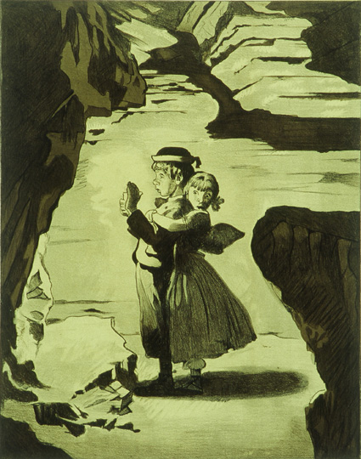

4. **Write a letter to your favorite actors** from this production. Tell them what you liked about the play, their performance, etc. Mail your letters to:

The Barter Players

c/o Barter Theatre

P.O. Box 867

Abingdon, VA 24212-0867

ATTN: Tuck Everlasting

5. Even though Muff Potter was innocent, he was viewed as guilty until Tom shared what he knew. What does “guilty” mean? How can we determine if someone is guilty? **Discuss.**

6. Superstitions are ideas that people believe are true even though they cannot be proven and may even go against nature. Tom and Huck go to the graveyard with a dead cat to cure Tom’s wart. Can you think of other superstitions**? Make a list** of them then take a poll to see who believes in them and who doesn’t. **Research superstitions about the theatre and present them to your class.** How did these superstitions begin?

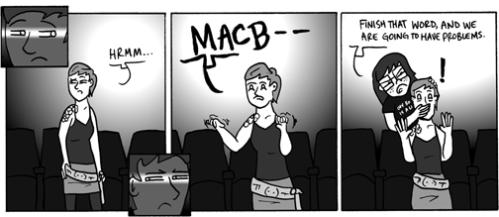

7. This play is set in 1845. Using the internet, research the differences between that time and the present. What did they do for transportation? For news? For communication? For fun? How did they see at night? **Present your findings to the class.** The setting for this story, St Petersburg, is based on Mark Twain’s hometown of Hannibal, Missouri. Locate Hannibal on a map of the United States. In what part of the country is it found? How did this setting influence the adventures of Tom and his friends? **Discuss how the time and setting of this story affected the plot.**

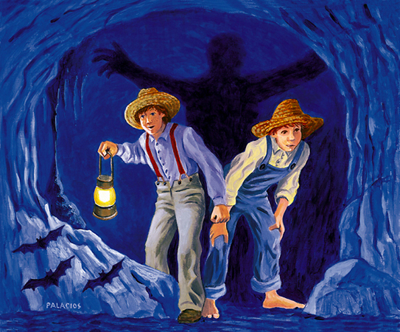

8. Read the book *Tuck Everlasting* by Natalie Babbitt, then make a list of the scenes/characters from the book that were left out of the play. Why do you think this was done? **Discuss.**

**7. Stage Manager**

The Stage Manager attends all the rehearsals and once the show goes into production, is “in charge”, calling all the sound and light cues and maintaining the integrity of the piece during its run.

**2. Director/Actors**

The director and actors begin the rehearsal process. The director “blocks” the play, which means he tells the actors where to move and stand and sit. The actors work on learning their lines, finding their character’s motivation and creating the world of the play. The length of a rehearsal process for a Barter Player production ranges from 30 – 40 hours spread out over 3-4 weeks, depending on the play.

**6. Lights/Sound**

Lights not only illuminate the actors and pull focus to various spots on the stage but, together with sound, help create a mood. Lights and sound can also, along with the set, help establish location. The sound of oars splashing, the light reflecting on the water and voila! We are in the boat with Tuck and Winnie! **Try it yourself!** Put together a soundtrack for your scene that establishes place and mood. Feel free to use recorded music/sound effects or perform it live!

**5. Props**

Mae’s music box! Miles’ fishing pole! The jail cell window! These are a few examples of the props designed and built by Barter’s props department for this production. A **prop** is defined as an object used on stage by actors for use in the plot of a theatrical production. **Try it yourself!** Design and build the props you will need for your scene.

**4. Costumes/Wigs**

The costume designer is responsible for creating a different look for each character while maintaining the overall aesthetic of the production. Each actor’s costume must be tailored to fit and be built to take the wear-and-tear of 6 shows a week *plus* tour! Also, in a show where the actor is required to play more than one character, the design must incorporate a method to facilitate “quick changes”.

The wig designer is responsible for designing, building and styling the wigs that will appear in the show. Like the costumes, wigs are necessary to help distinguish characters.

**Try it yourself**! Design a costume/wig for the character in your scene. Make sure your costume includes a mechanism to make “quick changes possible.

**1. Script**

It all starts here. A playwright (in this case, Mark Frattaroli) turns the prose of literature into dialogue and dramatic action. This is called “adapting”. Sound easy? **Try it yourself!** Pick a scene from your favorite story and adapt it into a scene for the stage. Try not to use the narrative voice – focus instead on creating “dialogue” between the characters.

**3. Set Design**

The set designer designs a set that will not only serve the aesthetic needs of the production by creating visuals that represent the various locations in the story (i.e. the tree, the lake, the jail) but also function as a safe environment upon which the actors will move (or be moved). A good set design will also allow the action to flow from one scene to another smoothly, with seamless transitions. **Try it yourself!** Using the scene you adapted, design a set that will both visually serve the story and function effectively for the actors.

**From the Page to the Stage!**

How does a book become a stage play? Here are some of the elements that went into the Barter Players’ production of ***Tuck Everlasting****…*

9. **Compare and contrast** the adventures Tom takes with his friends to the adventures Harry takes in the *Harry Potter* books by J.K. Rowling. What traits do Harry Potter and Tom Sawyer have in common? Imagine that Harry Potter and Tom Sawyer switched places. **Write a story about an adventure that Harry Potter and Huck Finn might go on in St. Petersburg.** What kind of mischief might Tom Sawyer get into at Hogwartz?

11. Describe the set used for the Barter Players’ production of *Tuck Everlasting*. How realistic was it? How were the set pieces used to convey place? Time? Mood? **Discuss.**

12. After reading *Tuck Everlasting* and seeing the play*,* compare the passage of time in each. How much time elapses between the opening scene of the book and the last page? Does the same amount of time pass in the play? How is the passing of time handled in the play? **Discuss the difference between dramatic action and exposition.** Does this explain why time may seem “collapsed” in a theatrical adaptation of a novel?

13. Angus Tuck is determined to keep his family’s immortality a secret and stop other people from drinking the spring water. The Stranger is just as determined to reveal the secret of the spring to the world. What motivates these two men? What does this story teach us about the wheel of Life**? Is immortality something to be desired or something to be avoided?** **Divide the class into two teams and debate this topic.** Support your position with stories from newspapers, magazines, books, etc. What was Natalie Babbitt’s opinion on the subject?



14. When the Stranger threatens to expose the secret of the spring and tries to take Winnie from the Tucks’, Mae clubs him over the head with her rifle. The whole event is witnessed by the Constable. Pick between the characters of Mae, Winnie, and the Constable. **Write a journal entry as that character the night after that event.** Compare your journal’s entries with those made by the other characters. **Discuss how point-of-view influences the documenting of an event.**

**Be Descriptive!**

**Read Mark Twain’s description of McDougal’s Cave below…**

“They wound this way and that, far down in to the secret depths of the cave… This shortly brought them to a bewitching spring, whose basin was encrusted with a frostwork of glittering crystals; it was in the midst of a cavern whose walls were supported by many fantastic pillars which had been formed by the joining of great stalactites and stalagmites together, the result of the ceaseless water-drip of centuries. Under the roof, vast knots of bats had packed themselves together, thousands in a bunch; the lights disturbed the creatures and they came flocking down by hundreds, squeaking and darting furiously at the candles…”

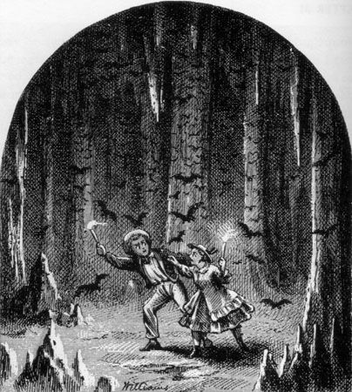

**Students:**

Find a picture of a person, place or thing from a magazine and **write a description of him/her/it in your own words**. Be as descriptive as possible.

**Teacher:**

Number the pictures and place them on one wall of the classroom. Give the students copies of the descriptions and see if they are able to match them to the appropriate picture!

**Write a critique of The Barter Player’s production of**

***Tuck Everlasting***.

Be sure to include descriptions and analyses of the individual performances, the directing/staging choices, and the design elements (costume, set, props, & sound). Why do you think some of these artistic choices were made? How would you have done it differently?

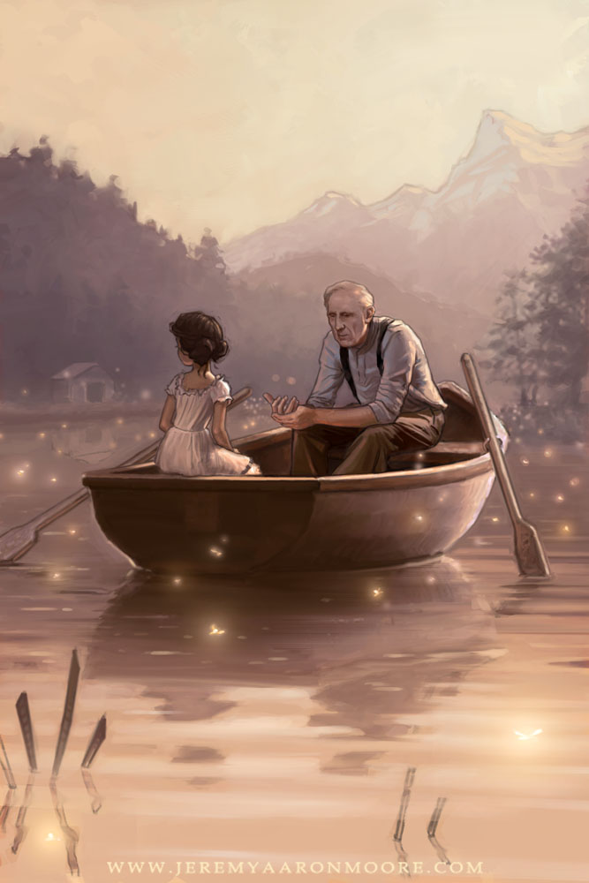

**How did the play compare to the novel? How do the structural elements of a play (using dialogue and action to tell the story) differ from that of prose? Discuss.**

In this play, one of the actors has to change quickly from playing character to character. What movements, gestures, and other forms of physical expression did she use to accomplish these changes? Did you think they were effective? How were costumes used? **Discuss.**

**Define *comedy* and *tragedy.***

Is *Tuck Everlasting* a comedy or a tragedy? **Cite three samples from the book to support your position.** How much does a character’s point-of-view determine whether an event is comic or tragic? **Discuss.**

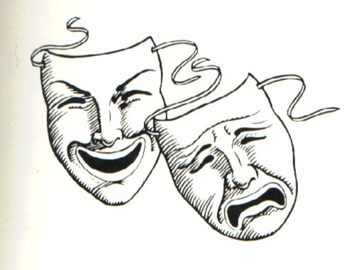

**Word Search**

Find the following words in the puzzle below: **August, dog days, Ferris Wheel, Treegap, Winnie Foster, Jesse Tuck, spring, toad, music box, Stranger, pond, Angus Tuck, jail, gallows, Toad, immortality, constable, cemetery, Mae Tuck, kidnap**

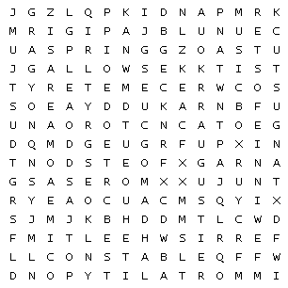

**True and False**

Write **T** if the statement is **True** and **F** if the statement is **False**.

1. ____ *Tuck Everlasting* is a novel written by Mark Twain.

2. ____ The Tuck family eats mushrooms that give them immortality.

3. ____ Winnie Foster lives with her grandmother.

4. ____ Mae, Miles and Jesse kidnap Winnie.

5. ____ The Stranger in the Yellow Suit wants to sell the spring water.

6. ____ Winnie helps Angus Tuck escape from jail.

7. ____ This story is set in the dead of winter.

8. ____ Natalie Babbitt grew up in Treegap.

9. ____ Mae kills the Stranger in the Yellow Suit.

10. ____ The Tuck family reunites every 10 years.

11. ____ Winnie pours the spring water over a toad.

12. ____ Mae owns a music box.

13. ____ Miles and Winnie go fishing but throw the fish back.

14. ____ Winnie drinks the water and spends eternity with Jesse.

**Matching**

Draw a line connecting the noun with its corresponding description.

1. Winnie Foster a. his wife left him

2. Treegap b. wears a yellow suit

3. Angus Tuck c. arrested Mae

4. Toad d. gives Winnie the spring water

5. Stranger e. compares Life to a wheel

6. Mae Tuck f. wants to run away

7. Miles Tuck g. Winnie’s “pet”

8. Constable h. escapes jail

9. Jesse Tuck i. the Tucks’ home

**Suggested Further Reading/Links**

**Other stories by Natalie Babbitt:**

*The Devil’s Storybooks*

*The Something*

*Phoebe’s Revolt*

*Nellie*

*Dick Foote and the Shark*

*Herbert Rowbarge*

*Kneeknock Rise*

*Goody Hall*

*The Eyes of Amaryllis*

*The Search for Delicious*

